Crop Recommendation using Random Forest ML Algorithm

In this project we have used Random Forest algorithm to recommend crop for the farmers based on rainfall, temperature and their soil nutrients. Random Forest will accept soil and temperature details from user as input and then recommend crop based on input values.

To run project double click on run.bat file to start python Flask server and get below output

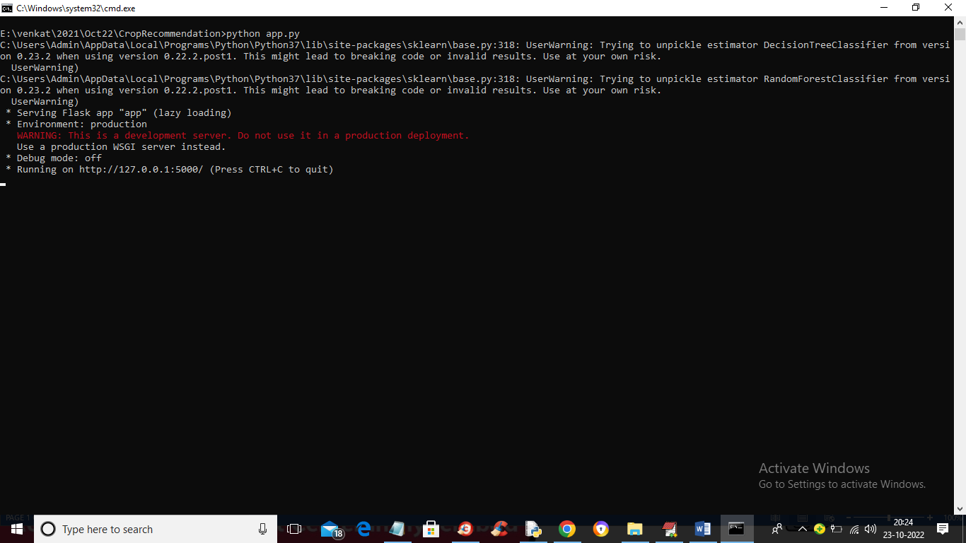

In above screen python FLASK server started and now open browser and enter URL as <http://127.0.0.1:5000/index> and press enter key to get below page

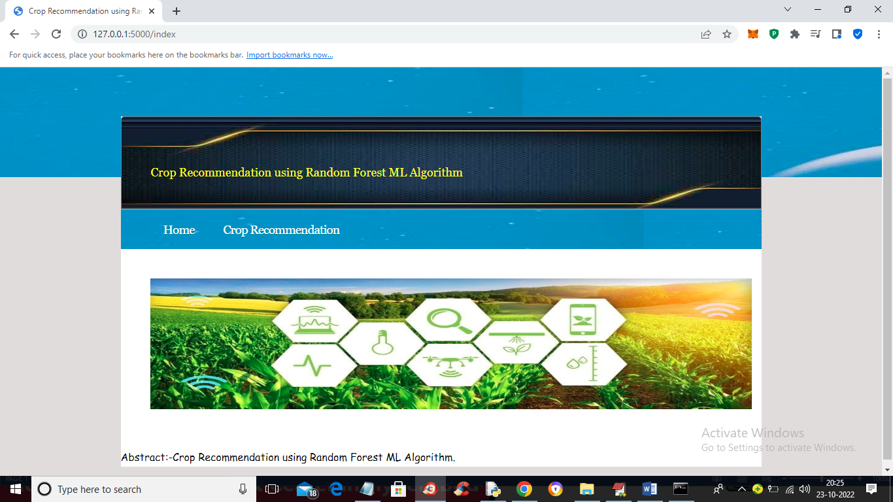

In above screen click on ‘Crop Recommendation’ link to get below screen

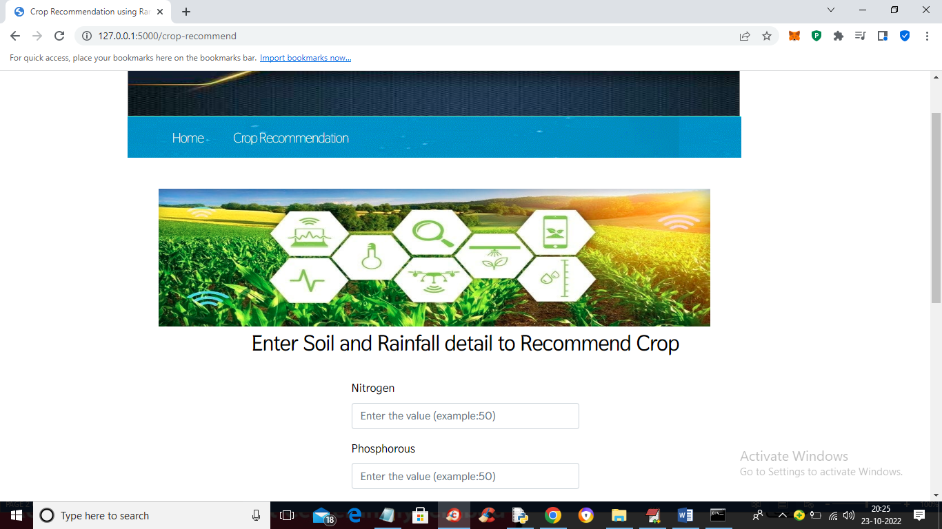

In above screen enter all values and press button (as your reference application contains all states and cities names so we have used same code for this screen)

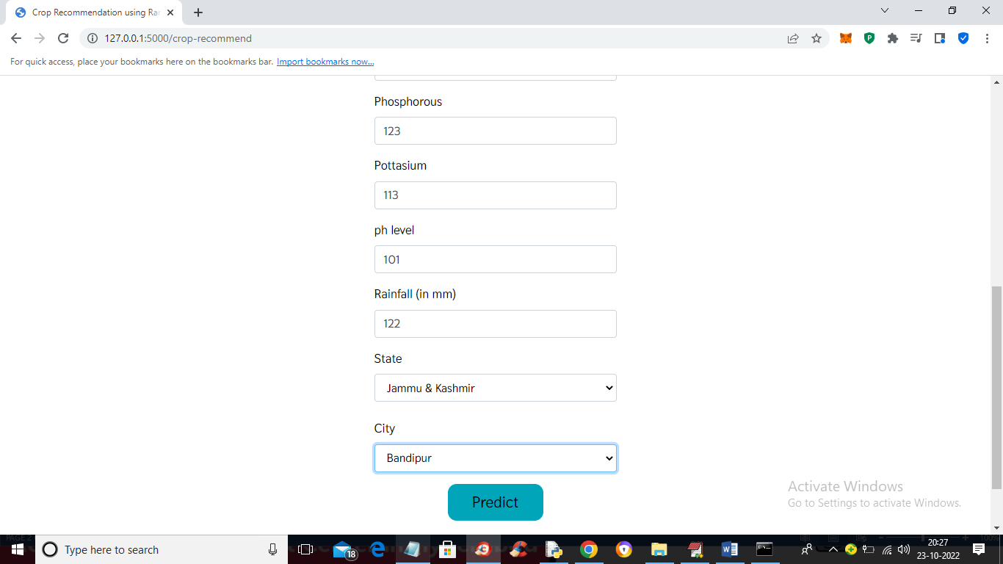

In above screen we entered some values and then click on ‘Predict’ button to get below output

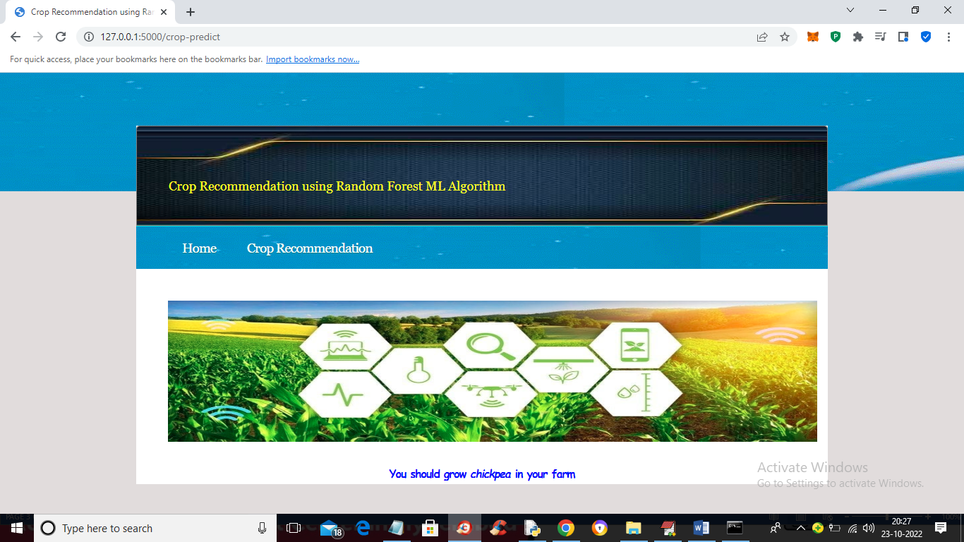

In above screen we got output as ‘chickpea’ can be grown and now try some other values

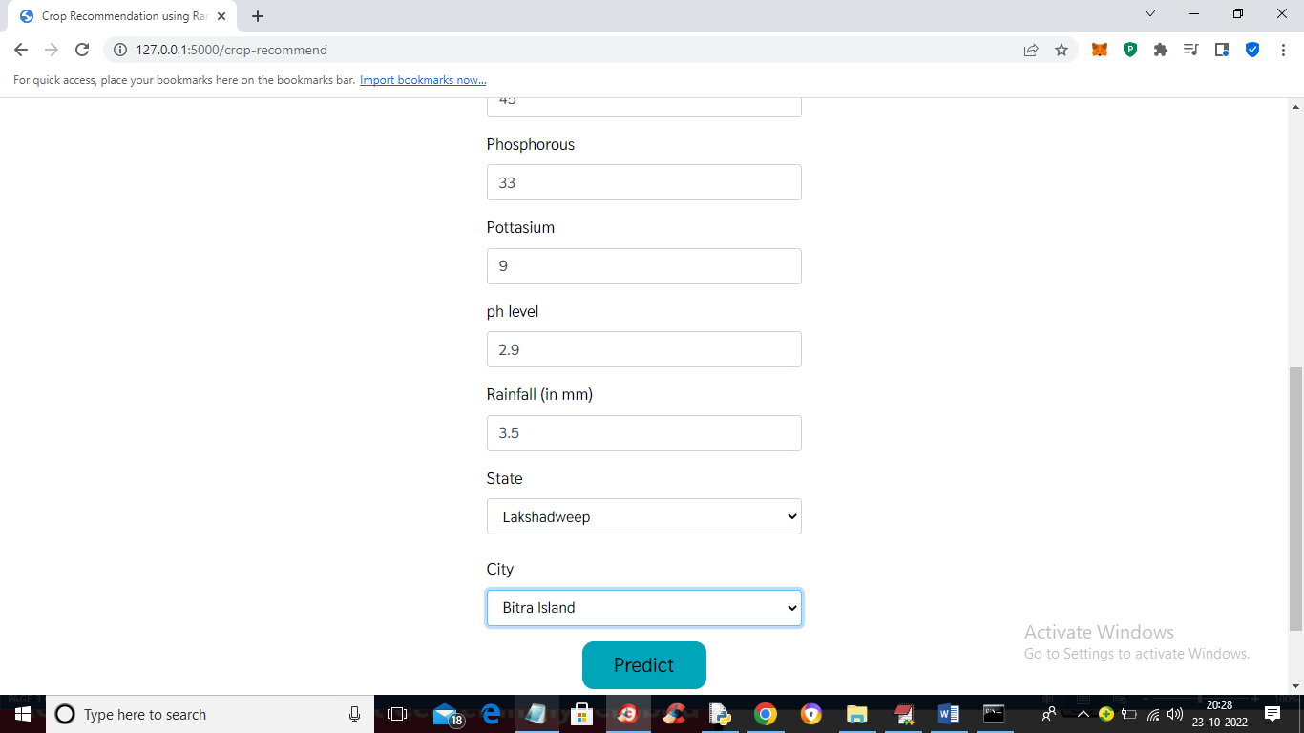

For above input will get below output



Try other input

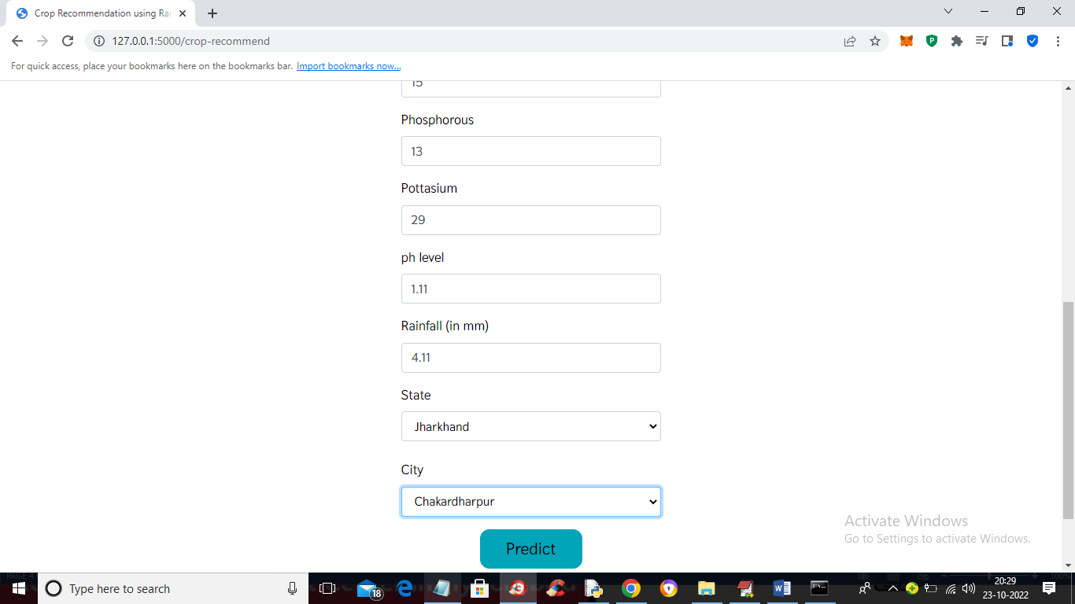

For above input will get below prediction

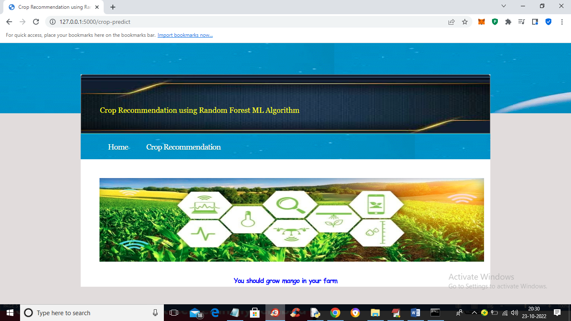

In above screen we got prediction as ‘mango’ to grow

Similarly you can use any values to get prediction or you can copy values from test.txt file